Programming Fundamentals
LeetCode Solution
Rana Muhammad Hussain
25K-0141
1.Running Sum:
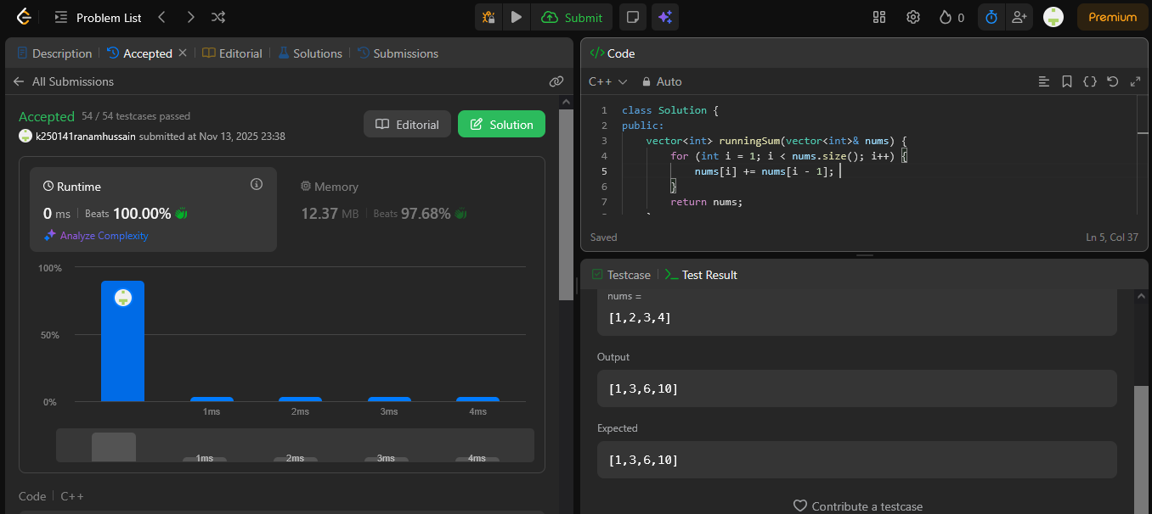
2.Transform Array by Parity:
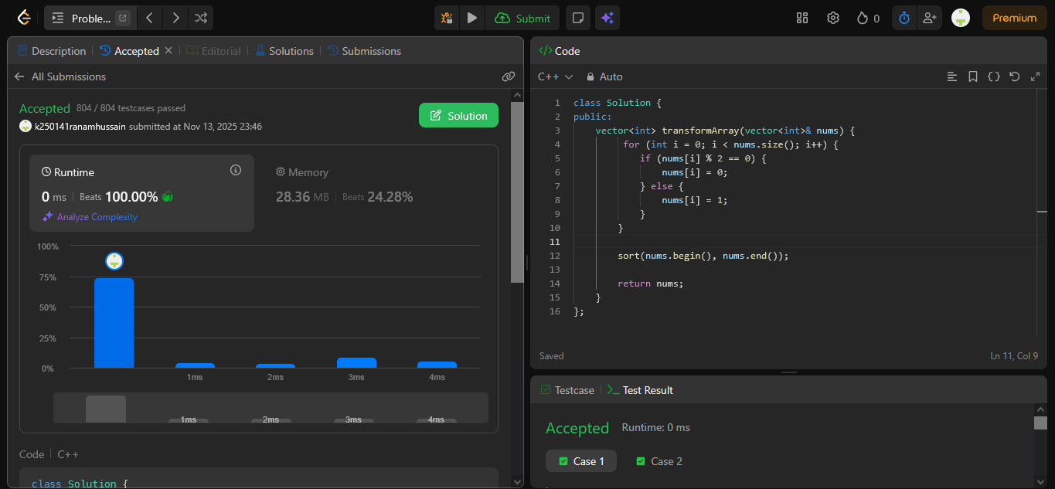
3.Array Shuffling Program:
